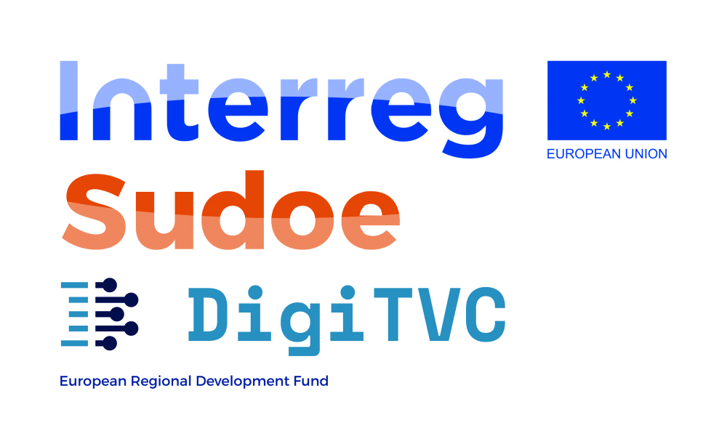

|  |
| --- |
| Digitization of the Textile Value Chain |
| Guide for Applicants |

|  |
| --- |
|  |

Table of Contents

1. DigiTVC Overview 3

2. Open Call 4

3. Who can Apply? 5

4. How to Apply? 5

5. Evaluation Process 6

6. Administrative Duties 7

7. Economic support scheme 7

8. Duration and Scope of the projects 8

9. Results and Deliverables 8

10. Services Delivery Model 8

11. Economic support to Beneficiaries and justification 8

A. BUDGET PLANNING GUIDELINES 9

B. GENERAL CRITERIA FOR ELEGIBILITY COSTS 9

C. ELEGIBLE COST CATEGORIES 9

D. INELIGIBLE COSTS 10

12. Publicity 10

13. Other Considerations 11

# DigiTVC Overview

Industry 4.0 and digitization represent a challenge and an opportunity for companies. For SMEs in the textile sector of the SUDOE space, which in recent years have suffered a significant slowdown, having methodologies and tools that allow them to have quick access to these new solutions can provide this differential added value to recover lost competitiveness and address its main challenges successfully: greater speed and flexibility, adapting to new market demands, more personalized products and services, greater traceability and specialization, and more efficient, productive and connected factories.

The transnational approach of the project, with the participation of entities from Portugal, Spain and France, will allow the results of the project to reach more than 5,000 textile companies in the SUDOE space. To solve these needs, DigiTVC will address the challenge of digitizing as follows:

1. Diagnosis of the critical digitalization needs of the textile value chain with a focus on specific in three areas: fashion, home textiles and technical textiles that will answer 3 questions: Which are the critical elements of the textile value chain that must be adapted so that companies be more competitive? What possibilities do technologies offer to make this interaction more efficient? and What is the current capacity of companies to adopt the technologies?
2. Carrying out at least 3 pilots that address and solve these challenges, in collaboration with startups, research centres or technology providers that develop viable 4.0 technology solutions and interest for the challenges of the sector.
3. Development and systematization of useful digitization protocols for all textile SMEs to starting from the results obtained in the pilots. The project also provides for the training of experts who can accompany companies in an individual to create their own digitization strategy from the protocols, as well as the development of an accreditation system of experts to guarantee a minimum standard of quality in the provision of their services.

# Open Call

DigiTVC is looking for textile companies who want to implement digitalization solutions to address and solve the challenges of: greater speed and flexibility, adapting to new market demands, more personalized products and services, greater traceability and specialization, and more efficient, productive and connected factories.

DigiTVC invites textile companies to submit a project proposal to the following challenges:

* Purchasing / supplier relationships.
* Production.
* Marketing / branding.
* Sales / customer relations.
* Human resources.
* Strategic development.

The DigiTVC call will remain open over the course of 1 month with one cut-off date. The DigiTVC call will be launched on 15 of April 2021 and will close the 17 of May at 17:00 hours CET.

* The proposal must include an explanation of the project and activities to be carried out during the implementation of the pilot.
* Projects must be implemented by a technology provider or specialist in the area which can implement digitalisation solutions to solve one or more of the challenges above commented.
* The pilot must be implemented in 2 textiles companies (e.g: customer-supplier relation) of the value chain by the technology provider.
* Match between textile company and technology provider can be proposed by the applicant. DigiTVC will check if the partnership is qualified and competent. In case there is no technology provider proposed, the DigiTVC consortium will select one from its database. Final decision and selection of technology provider will be made by the consortium.
* At least 3 pilots will be approved, minimum 1 per country (Spain, France, and Portugal).
* Each pilot will be funded with up to maximum of:

|  |  |  |  |
| --- | --- | --- | --- |
| **Region** | **Budget for services from the Technology Provider** | **Budget for Equipment and consumables** | **Contribution from DigiTVC consortium** |
| Spain | 27.000€ | - | Additional effort from AITEX (0.5 man-month) |
| Portugal | 8.500€ | 18.500€ | Additional effort from CITEVE (xxx man-month) |
| France | - | 23.000€ | Additional effort from ICAM (xxx man-month) |

There are 6 challenges where companies can apply and present their pilot ideas:

1. Purchasing / supplier relationships.
2. Production.
3. Marketing / branding.
4. Sales / customer relations.
5. Human resources.
6. Strategic development.

# Who can Apply?

Textile companies from all over the Spanish Autonomous Communities (except Canary Islands), the six Southwestern regions of France (Aquitaine, Auvergne, Languedoc-Roussillion, Limousin, Midi-Pyrénées and Poitou-Charentes), all continental regions of Portugal (thus excluding Madeira and Azores), United Kingdom (Gibraltar) and the Principality of Andorra are welcome to submit their proposals!

Applicants must be a SME (under the EU definition)[1], a start-up, **legally established** as a business under the national law and based in Spain, France, Portugal, UK and Andorra.

Awarded candidates must be legally established under the national law as of the signature of the project collaboration agreement between the company and technology provider and throughout the project duration.

# How to Apply?

All interested companies will be able to submit their application through the DigiTVC website during the open call. Applicants will fill in the online registration form. **Registration form must be complete in English**.

In this website, companies will be able to answer the questions and upload the documents asked in order to submit the proposal. Evaluation criteria is available here.

**Call will be opened from 15 of April 2021 to 17 of May 2021 (17:00 h CET).**

Figure 1. Call process diagram

The application form must be written in English and could be download from the DigiTVC website and must include the following sections:

* Business Impact (maximum 3 pages)
  + Solution to a clear business need or opportunity
  + Clear impact on business and process performance
  + Solution innovativeness
  + Circular economy and sustainability gains
  + Value-chain impact
* Technology innovativeness (maximum 3 pages)
  + Viability and maturity of the technology
  + Digital solution adoption
  + Company digital strategy
  + Potential to scale-up the pilot
* Operational structure (maximum 2 pages)
  + Quality of the workplan
  + Appropriate budget
  + Team competencies
  + Risk analysis

Beside this, companies must also submit a self-digital maturity questionnaire which will analyse the situation of the company. In this questionary the company must indicate if they have participated in previous initiatives and activities related to digitalisation.

# Evaluation Process

The evaluation process will have the following steps:

1. **Pre-selection made by the DigiTVC Technical Committee**. Maximum 4 members of the Technical Committee and 2 external experts of that challenge will evaluate the proposal.
2. **Technical Committee discussion.** Proposals passing the threshold will be discussed between the six experts, in order to ensure transparency in the evaluation process.
3. **Proposals must pass the following threshold for the evaluation criteria:**
   1. IMPACT criteria: minimum of 16 points
   2. TECHNOLOGY criteria: minimum of 14 points
   3. COST criteria: minimum of 10 points
4. The **Technical Committee** will select those proposals (at least one per country) with the best mark.
5. If selected, companies will be contacted by email. If not selected, companies will receive by email the evaluation results.
6. **Awarded companies announcement.** Awarded companies will be officially announced. Companies receive an e-mail and the list will be published in DigiTVC website on the 30 of June 2021.

The evaluation criteria will be detailed at the website.

# Administrative Duties

Selected applicants will become DigiTVC collaborators.

Collaboration contracts with beneficiaries will be managed by the Consortium. The administrative tasks for the beneficiaries, including activity reporting obligations and related documents will be provided during the agreement’s formalization.

Preparation of Collaboration Agreement.

The beneficiary will be requested to sign a Collaboration Agreement with the project. The main objective of this agreement is to stablish the collaboration between the textile company and the project and to validate the operational capacity from the partners and to establish rules for receiving support from the DigiTVC project.

Beneficiaries will have to submit proof of:

* Legal existence: Legal Entity Form accompanied with the supporting documents (registration, tax certificates). Legal entity form can be found [here](http://ec.europa.eu/budget/contracts_grants/info_contracts/legal_entities/legal-entities_en.cfm).
* Founders IDs
* Existence of a Consortium Agreement between the participants

# Economic support scheme

The technology providers from the applications selected, will receive the economic support by the DigiTVC consortium partners. Selected projects will be required to sign a Collaboration Agreement with binding details on the project time plan and goals and budget plan.

The economic support will be paid directly to the technology provider out in 3 tranches:

* At the signature of the collaboration agreement: 30% is paid out after signing of collaboration agreement.
* After the mid-evaluation: 40% is paid out after successful attainment of mid-goals (according to collaboration agreement) and mid-term report.
* After project finalization: 30% is paid out after successful finishing of project, required final report and project documentation, cost justification and final presentation.

# Duration and Scope of the projects

* The duration of the projects must be between 9 to 12 months maximum, starting from 1st of September 2021 to 31st of August 2022. Within this project time textile companies in collaboration with the technology provider must do the project and activities described in its proposal.
* Selected projects will commit to individual project goals (time, budget, project status) that are developed and evaluated according to the project proposal, together with the corresponding technology partner. During the project running time, companies will have to document their project status and progress.
* Additionally, companies commit to common milestones, coherent for all projects within the DigiTVC project. The common milestones refer to a mid-term report and a final report of project results.

# Results and Deliverables

The beneficiary will deliver periodic reporting through the platform:

* Monthly report (including monthly progress and problems encountered).
* Mid-term report (including technical draws, photographs, diagrams…) with a detailed description of the works carried out. Deadline: 18th of March 2022
* Final report (including a summary of the work done, detailed documentation and explanations). Deadline: 30th of September 2022

Reporting dates will be defined in the collaboration agreement.

# Services Delivery Model

Selected projects have a project run time between 9 and 12 months and are divided in 2 periods, starting date until Mid-Term Evaluation (Sept. 2021-Feb. 2022) and Mid Term Evaluation until project end (Mar. 2022 – Aug. 2022). The economic support will be paid in accordance with goals, milestones and reporting duties that will stated in detail within the collaboration agreement to be signed after selection.

# Economic support to Beneficiaries and justification

Beneficiaries of DigiTVC will be economically supported (see specific conditions by countries in in Section 2) to develop their pilot for digitalising any process or activity on one or more of the 6 challenges detailed in section of this document.

The exact economic support will be determined by the Technical Committee according to the scope of the project but will not exceed the amounts detailed in the table below:

|  |  |  |  |
| --- | --- | --- | --- |
| **Region** | **Budget for services from the Technology Provider** | **Budget for Equipment and consumables** | **Contribution from DigiTVC consortium** |
| Spain | 27.000€ | - | Additional effort from AITEX (0.5 man-month) |
| Portugal | 8.500€ | 18.500€ | Additional effort from CITEVE (xxx man-month) |
| France | - | 23.000€ | Additional effort from ICAM (xxx man-month) |

## BUDGET PLANNING GUIDELINES

Budget calculation is a mandatory part of the application. The described project has to be planned in time and budget and outlined in respective activities, considering necessary resources for the project (such as physical objects, technologies involved, materials, working time activity, etc.).

After selection, the budget and related costs categories with designated amount of euros will be a fixed part of the collaboration agreement. Applicants are asked to draft this budget and work schedule as realistic as possible in their application but may suffer modifications proposed by the technical committee before signing the grant agreement.

## GENERAL CRITERIA FOR ELEGIBILITY COSTS

In order to be eligible for DigiTVC funding, costs must meet the following criteria:

* be implemented in the company selected to develop the pilot and during the duration of the pilot.
* be indicated in the estimated overall budget included in the proposal and signed in the contract.
* be necessary for the implementation of the activity.
* be identifiable and verifiable, in the accounting records of the DigiTVC partner that assists the pilot.
* comply with the requirements of applicable tax and social legislation. Value added tax (VAT) is considered as eligible where it is not recoverable under the applicable national VAT legislation and is paid by the beneficiary other than a non-taxable person as defined in the first subparagraph of Article 13(1) of Directive 2006/112/EC on the common system of value added tax.
* be reasonable, justified and comply with the principle of sound financial management, in particular regarding economy and efficiency.

## ELEGIBLE COST CATEGORIES

The eligible costs for the activities are those costs which, provided that they satisfy the criteria of eligibility set out above, are identifiable as specific costs directly linked to the performance of the activities and which can therefore be attributed to it directly.

In particular, the following categories of direct costs may be considered eligible and may be included as a service pack offer:

|  |
| --- |
| Eligible cost categories |
| Other direct project cost |
| * Technology provider costs for implementing the digitalisation solution. * Material costs**\*:** Provided by the technology provider, needed for the implementation of the system, and directly linked for the execution of the project. * Equipment costs:   + Provided by the technology provider, needed for the implementation of the system, and directly linked for the execution of the project. |

* Should fulfill the principle of the best value for money, i.e. the best price-quality ratio.

## INELIGIBLE COSTS

The following costs are ineligible and therefore not accepted:

|  |
| --- |
| Ineligible costs |
| * travel costs. * subcontracting of other services not provided by the technology provider). * Additional equipment not offered by the technology provider. * Additional materials or consumables not offered by the technology provider. * costs for contributions in kind: these are contributions that are not invoiced, such as voluntary work, equipment or premises made available free of charge). * deductible VAT. * Indirect project costs |

# Publicity

All companies supported by DigiTVC are required, in case they make any publication or dissemination, to clearly mention the fact that they have received economic support from the Interreg Sudoe programme and through DigiTVC project in any publication, in other information or promotional materials, and during activities (conferences or seminars, etc.), for which the grant is used, using the following wording: " The DigiTVC project is co-financed by the Interreg Sudoe Programme".

The logo of DigiTVC project logo will be provided in order to be included in all the promotional material to be developed.

Companies economically supported by DigiTVC are obliged to allow DigiTVC partners to disseminate public information regarding the pilot.

# Other Considerations

**Data Protection:**

DigiTVC partners are committed to protect and respect applicants' privacy. The personal data collected in the context of the present Open Call will be processed in accordance with the Data Protection Directive 95/46/EC in regard to the processing of personal data and on the free movement of such data. Applicants files will be retained in DigiTVC archives until the end of the project activities for which the applicants submitted a proposal idea.

The information you provide will be used for the purposes of assessing or managing your application, and for other purposes connected with the DigiTVC project and your participation within it. The information you provide may be shared with other applicants, participants and statutory bodies connected with DigiTVC, mostly for statistical purposes. The information may also be shared with project partners’ sponsors and agents. We will retain your information on our files and contact you about other projects we may run that we believe could be of interest to you. If you do not wish for your information to be retained for these purposes, and would not like to be contacted about other projects, you may let us know using the email privacy@DigiTVC.eu.

The information you provide will be retained in compliance with the regulation (EC) 45/2001 of the European Parliament and of the Council of 18 December 2000. It will be entered and held securely on the DigiTVC computer systems and online databases. It is possible that the information we collect from you could be transferred, stored and processed in a destination outside of the European Economic Area (EEA) during the course of our processing. By submitting your information, you agree to this transfer, storing and processing, even where the country or territory in question does not maintain similar data protection standards.

By signing or submitting this form, you agree to allow us to process your personal data in accordance with this statement.

It is possible to exercise your opposition rights through the private profile of the entity (deleting your profile) or by contacting DigiTVC data controller by sending an email to privacy@DigiTVC.eu.. If you wish to contact us about the data we hold about you, please use the email privacy@DigiTVC.eu.

Useful Documents (available on the project the website):

* Application form template
* Evaluation criteria

Learn about the selection process, know how evaluators will score your proposal and how you need to upload certain documents on your proposal in order to be awarded.

**Questions**

For further enquiries, you can contact us through the following email: [helpdesk@DigiTVC.eu](mailto:helpdesk@re-fream.eu)

The mere fact of participating in this Open Call means that the participants know and fully accepts the present rules.

1. What is an SME? (<http://ec.europa.eu/growth/smes/business-friendly-environment/sme-definition_en>)