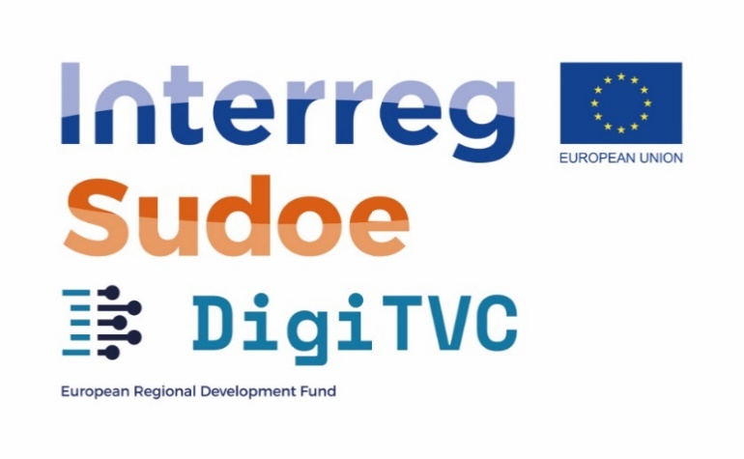

**SOE3/P2/E0866**

**GT 2 VALUE CHAIN DIGITISATION CHALLENGES AND OPEN INNOVATION**

2.3. Call of Pilots

Application form

**DELIVERBLE 2.3.1**

|  |  |
| --- | --- |
| **Title of your proposal:** |  |

|  |  |
| --- | --- |
| **Applicant Company:** |  |
| **Country:** |  |
| **E-mail:** |  |

|  |
| --- |
| **IMPORTANT INSTRUCTIONS:**  Write your application only in English and use typography: “Times New Roman” size 11. Line spacing: Exact 12 pt.  Before submitting please, eliminate the comments in *grey italics* |

# Business Impact *(maximum 3 pages)*

## Solution to a clear business need or opportunity

*What is the problem or the challenge you want to address in your company? What is the current approach? What is the proposed digital solution and how it will you address your problem / challenge?*

## Clear impact on business and process performance

*What are the expected improvements and changes on your processes and / or business model? What key-performance indicators will you use to assess the impact of the pilot? What are the expected targets?*

## Solution innovativeness

*How innovative is your solution regarding more traditional approaches and solutions, in terms of management practices, procedures and digital technology involved? Identify and describe the competitive advantages of your solution over other existing solutions.*

## Circular economy and sustainability gains

*In terms of processes and products, what are the expected gains for the sustainability of your business and/or impacts on the circularity of your products? Less energy consumption, less pollution, …? What KPI would use to assess those impacts? What are the quantified objectives you want to reach?*

## Value-chain impact

*What are the impacts you expect to have on your supply-chain, customers and / or suppliers? Does your solution have a direct impact on the supply-chain?* *Is there any other textile company (apart from the SME'S applicant) that will be involved and benefited or because of the implementation of your project? Which company? Why?*

# Technology innovativeness *(maximum 3 pages)*

## Viability and maturity of the technology

*What is the current TRL of the digital solution proposed for this pilot? Is it an off-the-shelf technology? What efforts were made to validate the feasibility of the digital technology?*

## Digital solution adoption

*Describe the changes you need to make in order to adopt the envisaged digital solution by your team, regarding management practices, procedures, new digital skills, etc. What impact this solution will have on your IT infrastructure?*

## Company digital strategy

*Describe the current digital strategy of your company. Describe some of the recent digital initiatives in your company. Describe the team and the management structures in place to manage your digital strategy?*

## Potential to scale-up the pilot

*How do you pretend to scale-up the pilot, if it is successful? What resources are needed to scale-up and how do you pretend to ensure those resources are available?*

# Operational structure *(maximum 2 pages)*

## Quality of the workplan

*Describe and explain the plan of activities that you will follow during this pilot (e.g. technical development, testing, assessment, training, etc.). How do you will validate the pilot? Describe your plan using a gantt chart (consider project duration: September 2021 – August 2022), with the expected deliverables and milestones.*

## Appropriate budget

*Detail all the investment you have already made to reach the current situation, and the expected investment for this pilot.*

|  |  |  |
| --- | --- | --- |
| **TYPE OF COST** | **Investment already made to reach the current situation** | **Expected investment for this pilot** |
| **Technology Provider** |  |  |
| **Material Costs** |  |  |
| **Equipment Costs** |  |  |
| **Company Staff dedication** |  |  |
| **TOTAL** |  |  |

## Team competencies

*Describe the team members for this pilot and their value for the success of it.*

## Risk analysis

*Present your risk assessment of the development of the pilot and the actions and strategies to avoid and mitigate the identified risks.*

*COMPLEMENTARY INFORMATION*

|  |  |  |
| --- | --- | --- |
| **Other public funding received** | | |
| Questions | Answers | Comments |
| Have you already participated in other EU projects? Do you have experience in this type of project? If yes, please indicate which projects and under which program. | Y/N |  |
| Please briefly describe the project and the activities you implement(ed). |  | |
| Have you already participated in other National/Regional projects? Do you have experience in this type of project? If yes, please indicate which projects and under which program. | Y/N |  |
| Please briefly describe the project and the activities you implement(ed). |  | |

This technical application form contains confidential technical and business information. All DigiTVC project partners and Selection Committee members have signed non-disclosure agreements (NDA).

|  |  |
| --- | --- |
| **Organisations** | **Selection Committee members** |
| ACCIÓ, ES | David Marco |
| ICAM, FR | Florent Bonal/Antoine Baczkowski |
| Citeve, PT | João Nuno Oliveira |
| Texfor, ES | Anna Ribé Gallart |
| Eurecat, ES | Daniel Blanco |
| External expert 2 | ??? |